RMU Intern Tracking System

Charles Gross

Robert Morris University

Dr. Karen Paullet

INFS 3220 Systems Analysis & Design

##### Section C1: Online

##### April 19, 2014

SYSTEMS PLANNING

To begin building RMU’s new intern tracking system, I would start at the planning phase by conducting a preliminary investigation in “order to study the systems request and recommend specific action” (Shelly & Rosenblatt, 2012, p. 71).

First, in order to understand the problem or opportunity, I would review the information that has already been provided in the systems request. As the request is for an entirely new information system to replace a manual system, I would analyze the information provided about the existing system to “determine which departments, users, and...processes are involved” (Shelly & Rosenblatt, 2012, p. 73).

The initial analysis reveals the problems that the new system will need to solve: the various groups of users use manual processes, paper forms, fax, and postal mail to move data between them. This results in the slow movement of information, with multiple potential places for data loss, as well as a system that is not user-friendly and has likely resulted in both students and companies opting not to participate due to these factors. Thus the root cause of these problems is the lack of an existing electronic information system that automates and streamlines the internship management process.

Given those problems with the existing system, the project’s scope is to allow all user groups for internship management at RMU to fully track all steps of student internship from student application to final evaluation. Given that RMU has existing website infrastructure, the primary constraint for the new system will be integration with Sentry Secured Services. Additionally, the time and cost to implement the system will be constraints as the solution must be active before the beginning of the Fall 2014 semester and be either at or below the cost of similar off-the-shelf solutions.

Next, I would perform additional fact finding in the form of interviews with students, advisors, career services, and internship company supervisors in order to “gather data about project usability, costs, benefits, and schedules” (Shelly & Rosenblatt, 2012, p. 77) beyond what has already been provided in the systems request. Specifically, these interviews would be conducted with the goal of expanding upon the manual system’s user groups, their roles, and their respective processes to facilitate internships.

After analyzing the data gathered from that fact finding, I would then evaluate the project’s feasibility using “four main yardsticks...operational feasibility, technical feasibility, economic feasibility, and schedule feasibility” (Shelly & Rosenblatt, 2012, p. 66). Since this project entails an entirely new system, this step would likely be the largest effort in the preliminary investigation. Given that RMU’s existing web infrastructure has already been designed to scale with student growth, the project would be operationally and technically feasible. Since the project’s few constraints seem to match the same issues faced by other universities with a similar problem, the project would be feasible both economically as well as financially.

Lastly, I would present all of my findings to the RMU President and representation from the faculty, career services, and the student body in the form of a Preliminary Investigation report that includes “an evaluation of the systems request, an estimate of costs and benefits, and a case for action” (Shelly & Rosenblatt, 2012, p. 66). The case for action in this instance would be a specific recommendation to move forward into systems analysis phase.

SYSTEMS ANALYSIS -REQUIREMENTS MODELING

As a successful analyst must first “determine the requirements before starting the design process” (Shelly & Rosenblatt, 2012, p. 139), I would begin the systems analysis phase for the Intern Tracking system with the creation of a requirements model. As that model is built from the results of additional fact-finding, I would use the fact-finding techniques of the data from the initial interviews and observation of the manual system in action to gain “additional perspective” (Shelly & Rosenblatt, 2012, p. 164), as well as sampling the existing records for students that have completed internships through the manual process.

The observation of the manual process will ensure that the processes described in the interviews truly “operate as they are described” (Shelly & Rosenblatt, 2012, p. 66).

For the sampling of the manual system’s data, I would use stratified sampling by selecting one hundred prior interns from each undergraduate grade level as well as one hundred from the graduate level so that there is “fair representation of the overall data” (Shelly & Rosenblatt, 2012, p. 168).

From the interviews, observations, and sampling of prior data, I would have enough facts to represent the requirements of the new system’s inputs, outputs, processes, performance, and controls.

The systems requirements for the Intern Tracking System are as follows:

* Outputs
  + Students, advisors, and career services must be able to see student internships that have been applied to, are in progress, and have previously been completed.
  + Advisors, career services, and supervisors must be able to see all submitted, approved, and past internship job postings.
  + Students, advisors, and career services must be able to see final evaluations.
  + Students must be notified of internship interview requests.
* Input
  + Company supervisors enter available internships at their company, approve student applications, enter intern progress, and finalize evaluations.
  + Career services approves internships submitted by companies and answers help requests.
  + Students apply to internships, enter their progress, and finalize evaluations.
  + Faculty advisors approve internships, student applications, and view/comment on student progress.
* Process
  + The internship tracking system must interface properly with Sentry Secured Services.
  + The system must notify users via email when they are required to perform an action like approve a posting or approve a student application.
  + The system must again notify users, when after 72 hours, they have not fulfilled an action required on their part.
  + The system must not automatically reject students applying to a position that their advisor previously declined.
* Performance
  + The system must support the entirety of the student body, faculty, and RMU career services.
  + Response time must not exceed 2 seconds.
  + The system must be operational seven days a week, 365 days a year.
* Control
  + The system must provide logon security at the website level, using Sentry Secured Services accounts.
  + The system must provide logon security for company supervisors by providing access that is limited to only the Intern Tracking system.
  + Group specific functions must be limited to their respective groups.

Beyond the system requirements, scalability and total cost of ownership are part of the requirements model, but they are not considered concerns for the new Intern Tracking System. As one of the requirements is integration into Robert Morris’ existing web infrastructure and given the relative simplicity of an intern tracking system, the scalability and total cost of ownership concerns have been folded into the scope of the existing RMU website.

SYSTEMS ANALYSIS – REQUIREMENTS, DATA AND PROCESS MODELING

Once the requirement model is completed, I would then begin the process of data and process modeling by creating a functional decomposition diagram (FDD) to “show business functions and break them down into lower-level functions and processes” (Shelly & Rosenblatt, 2012, p. 150). This first graphical model will be the initial top-down representation of the entire system from which all subsequent diagrams, as well as programming modules are created.

In developing the FDD, I separated the users into four separate user groups: students, faculty advisors, company supervisors and Career Services based on their function within the system.

Then, for each user, I broke down the general category of functions that those users could be expected to perform in the system. Finally, I broke those categories of functions down into specific functions. For example, students have an application process and an internship process. The application process has two lower level processes of applying to an internship and requesting help with the application.

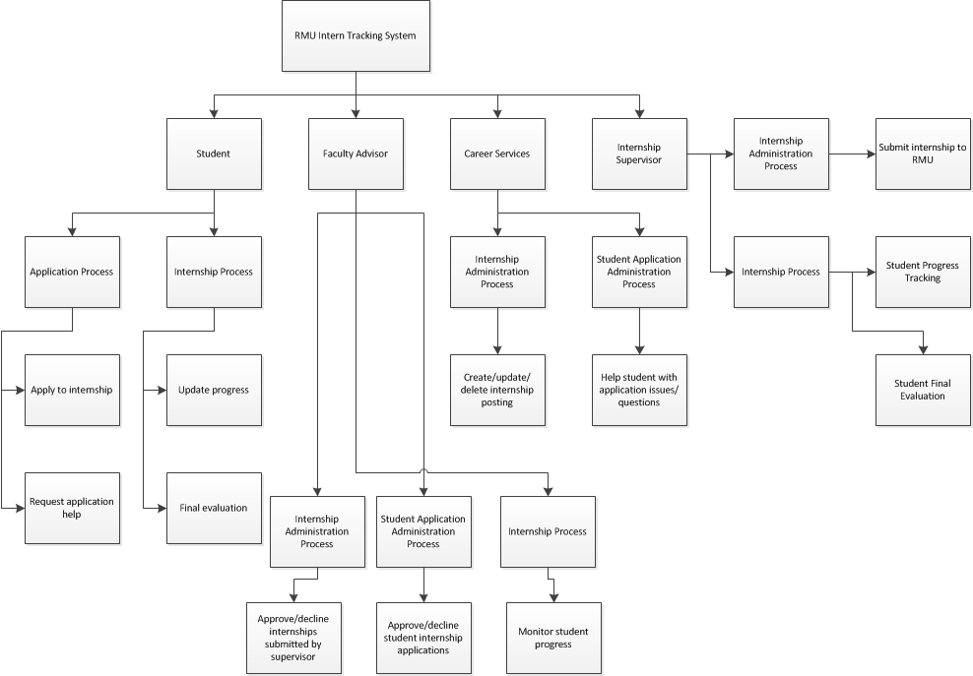

With a high level overview of the new system, and its hierarchy of processes in place, the next step would be to further describe how the information system should operate. A set of data flow diagrams will be created in order to provide a “logical model that shows what the system does” (Shelly & Rosenblatt, 2012, p. 200), specifically showing what the system does to transform “input data into useful information” (Shelly & Rosenblatt, 2012, p. 200).

The first data flow diagram in the set would be the context diagram, which is a “top-level view...that shows the system’s boundaries and scope” (Shelly & Rosenblatt, 2012, p. 208). While the functional decomposition diagram also was a top-level, the context diagram is specifically a top-level view of how data flows in and out of the system rather than a breakdown of the system’s processes.

I would first review what I had previously created in the FDD diagram, and then the system requirements in order to “identify the entities, the name and context of the data flows, and the direction of the data flows” (Shelly & Rosenblatt, 2012, p. 208).

The entities, which are “data origins or final destinations” (Shelly & Rosenblatt, 2012, p.205) are the same as the groups for the processes: Student, Company Supervisor, Faculty Advisor, and Career Services. These entities and their respective data flows in and out of the Intern Tracking system are shown below in the context diagram.

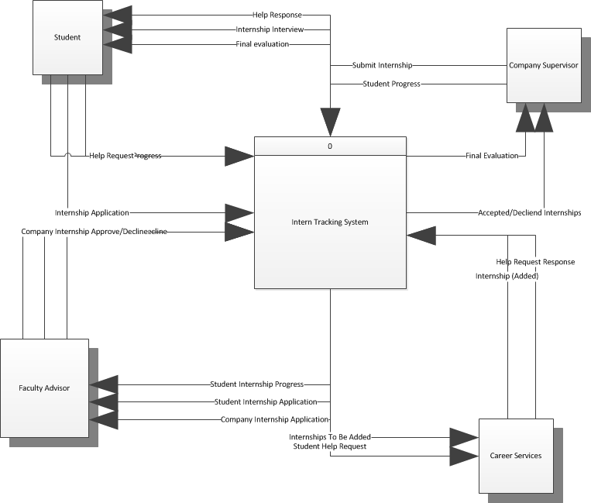

After the context diagram is completed, I would then create Diagram 0 by repeating the entities and data flows from the context diagram which shows “major internal processes, data flows, and data stores” (Shelly & Rosenblatt, 2012, p. 209). While the Intern Tracking system’s Diagram 0, as shown below is rather complicated, each process shown is a functional primitive and thus not exploded further. Since a lower level diagram is not needed, Diagram 0 represents the logical design of the Intern Tracking system at this stage. The details of the functional primitives will be stored in the project’s data dictionary, which is “a central storehouse of information about the system’s data” (Shelly & Rosenblatt, 2012, p. 217).

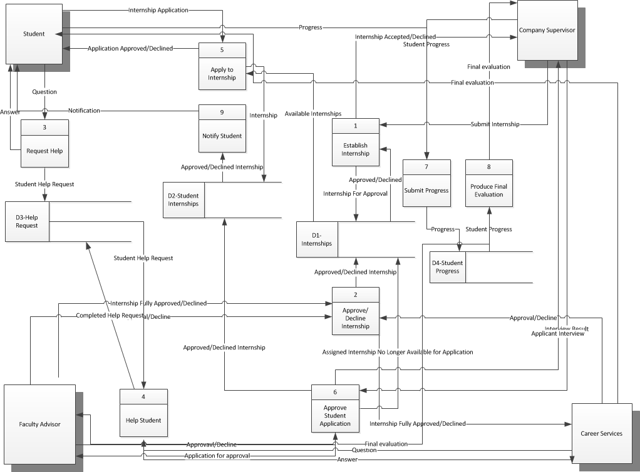

When this design is “implemented as a physical system, programmers will transform each functional primitive into program code” (Shelly & Rosenblatt, 2012, p. 211) using the information about the logical design from the data dictionary.

After the details of the functional primitives are added into the data dictionary, I would then use process description tools to “break the processing steps down into smaller units” (Shelly & Rosenblatt, 2012, p. 224) so that modular coding structures can be programmed from these units. I would analyze all of the functional primitives discovered during the data modeling and use the resulting information to first create a decision table for each primitive in order to fully understand it and to ensure that I have “considered all possible situations” (Shelly & Rosenblatt, 2012, p. 226).

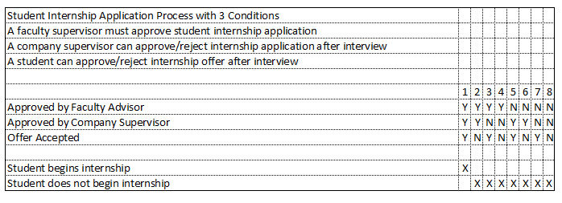

Once the decision table is created, I would then graphically represent that logic in a decision tree as a “horizontal form that resembles a tree with roots at the left and the branches to the right” (Shelly & Rosenblatt, 2012, p. 230).

As the most important process in the Intern Tracking system is the Student Application process, the decision table and tree for this process have been included below. In the case of the student internship application process decision tree, there are only two unique outcomes: the student begins the internship or the student does not begin the internship. This is due to the requirement that the faculty advisor and the company supervisor approve the application and that the student accepts the offer if one is given.

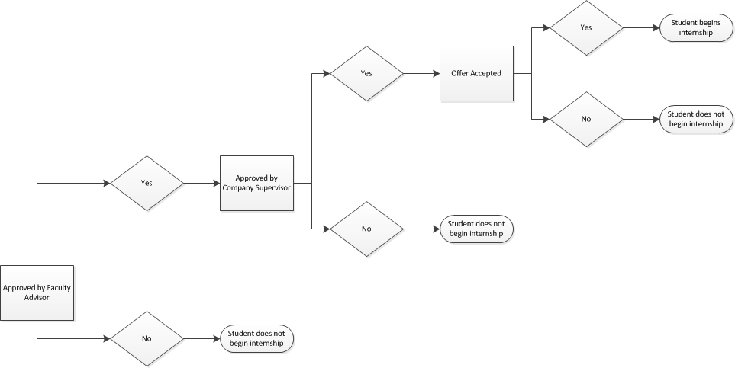

With the decision trees and tables done, data and process modeling would be completed resulting in the end product of a “logical model that will support business operations and meet user needs” (Shelly & Rosenblatt, 2012, p. 232). This logical model was created using structured analysis rather than an object modeling approach as I did not find the additional complexity of the interaction of objects and classes suited the simple requirements of the intern tracking system.

DEVELOPMENT STRATEGY RECOMMENDATION

The final step in the systems analysis phase would be the exploration of the development strategies. As the analyst for this project, my end goal for this step would be to make a specific recommendation for a development strategy.

As part of the development strategy recommendation, I would recommend that the Intern Tracking System be entirely web based. Given that multiple companies need to access the system on their own networks, as well as students who may need to access it off campus; a traditional system development approach would not satisfy user requirements.

Next, I would evaluate what other universities are using for similar purposes to see if there is a viable off-the-shelf alternative to developing the Intern Tracking System in-house. Universities such as St. Thomas University (University of St. Thomas, n.d.), California State University (Intern Placement Tracking, n.d.), and Brigham Young University, all use something called Intern Placement Tracking by Alcea Software (Alcea Software, n.d.), which initially seems like a viable alternative to developing the system in-house. Unfortunately, while this software would meet many of the RMU Intern Tracking system requirements, it does not integrate with any existing login systems so it does not meet the requirement of integration with Secured Sentry.

Requesting modification from Alcea Software or another software vendor may be an alternative; however, I believe that developing the software in-house will allow Robert Morris University to “minimize changes in...procedures and policies” (Shelly & Rosenblatt, 2012, p. 294) as well as “develop internal resources and capabilities” (Shelly & Rosenblatt, 2012, p. 292). I recommend that RMU commit the initial development cost to custom building their own system so that as the university continues to grow, the intern tracking system can be more easily modified to changes in how RMU handles the internship process without relying on “an outside firm for vital business support” (Shelly & Rosenblatt, 2012, p. 295).

References

Alcea Software. (n.d.). *Alcea Software*. Retrieved April 13, 2014, from https://www.alceasoftware.com/alcea/overview.html

Intern Placement Tracking (IPT). (n.d.). *- School of Social Work*. Retrieved April 13, 2014, from https://www.csuchico.edu/swrk/programs/field/ipt.shtml

Shelly, G., & Rosenblatt, H. (2012). *Systems analysis and design*. (9th Edition ed., p. 31). Boston MA: Course Technology Cengage Learning.

University of St. Thomas. (n.d.). *School of Social Work : Intern Placement Tracking*. Retrieved April 13, 2014, from http://www.stthomas.edu/socialwork/fieldprograms/ipt/